EB+ Leaking Modulator Valves

We have had several cases of reported leaking EB+ Modulator valves. However when the trailers have been inspected the cause has found to be a leaking spring brake chamber or in several cases multiple leaking brake chambers.

We would ask that before a valve is changed for a reported leak that the brake chambers are checked.

If the leak occurs when the truck hand brake is applied (Park on air truck) then the pipes going to the emergency side of the spring brake chamber should be removed from the QRV on a Gen 1 or the Spring brake feed ports on a Gen2. You can remove all the pipes at once if enough blanking plugs are available or 1 at a time. Once the pipe or pipes have been removed re-apply the handbrake and then check the pipe which is still connected to the brake chamber emergency side. Any air coming back through this pipe is leaking through the centre seal on the brake chamber and therefore the brake chamber will need to be replaced.

If the leak is present without the brakes applied then remove the pipes from the service ports in the EBS modulator and with red line connected check the removed pipes for any sign of air coming back through the pipe. Any air coming back through this pipe is leaking through the centre seal on the brake chamber and therefore the brake chamber will need to be replaced.

Schematics of the most common EB+ Generation 1 and Generation 2 system are attached.

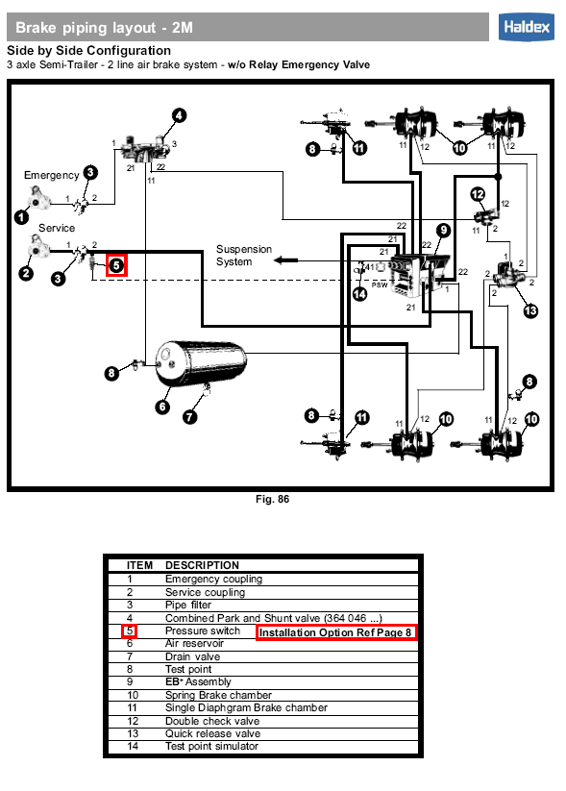

Valve leaking when truck handbrake applied
Blank ports

Valve leaking without handbrake applied

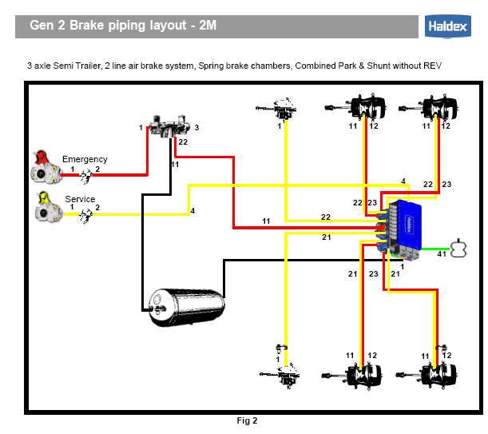

Valve leaking when truck handbrake applied

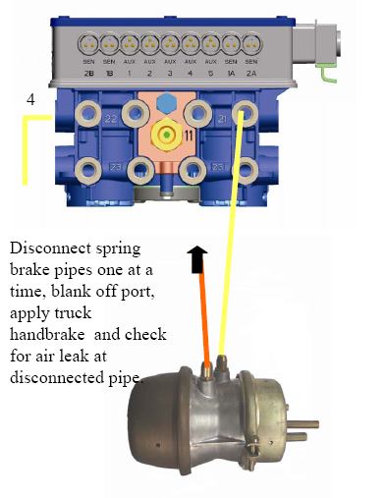
Blank ports

Valve leaking without handbrake applied

Blank port

If the chambers are found to be OK then the integrated DCV can be checked refer to technical sheet 000 700 329 for Gen 2 and 000 700 319 for Gen 1. Inspect the actual shuttle for any sign of damage.

Finally remove quick release valve and check diaphragm for any particles of swarf etc.

