Reporting a Defect for Owned Trailers

1. Go onto Fleet Assess website - [www.fleetassess.co.uk](http://www.fleetassess.co.uk)

2. Click Customer Login on the top right hand corner of the home page and login in with your details.

3. You will see the RFM live menu for your account, as below, click Report a Defect.

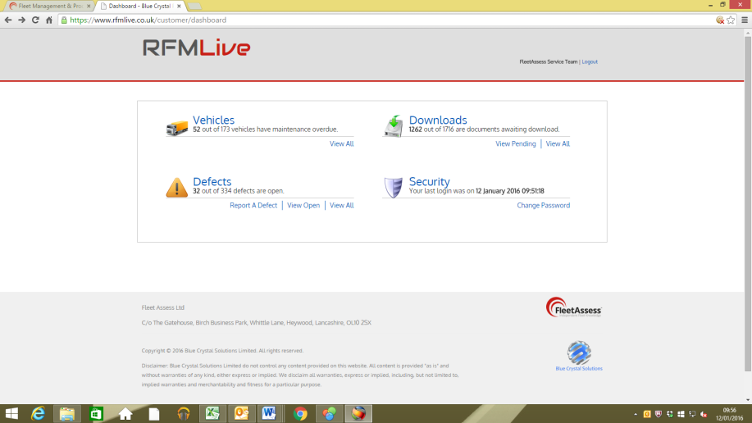

4. Complete the on-line defect form as below

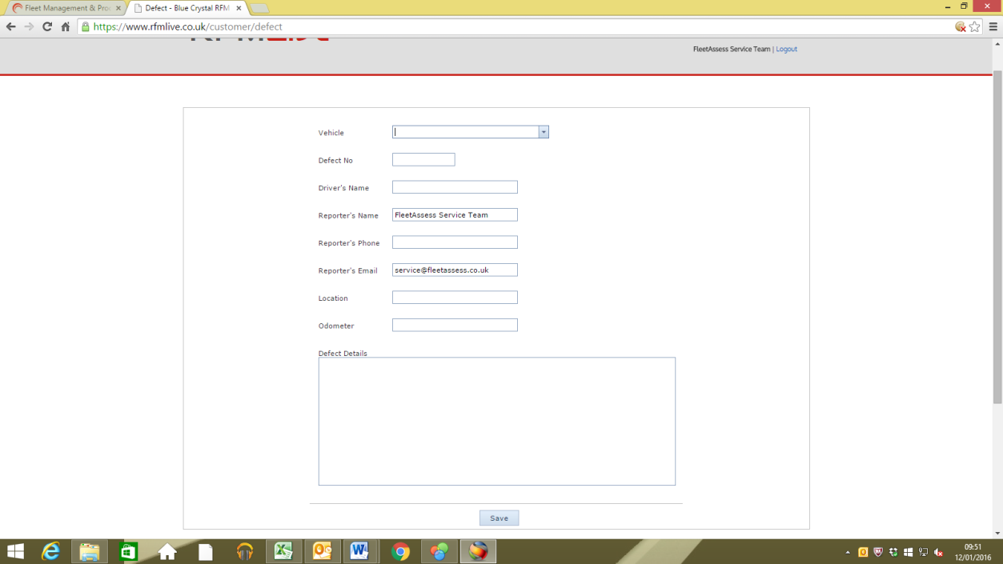

* Vehicle - type in trailer number
* Defect No. – DO NOT FILL THIS IN
* Drivers Name - Type full drivers name
* Reporters Name – This will auto populate with senders details
* Reporters Phone Number - type in the contact number of the person entering the defect
* Reporters email - this will auto populate
* Location - type in the vehicle location
* Odometer - no required to be completed
* Defect Details - enter clearly the defect details so the repairs can be actioned from this information

5. Once all the information is entered, click save. This will upload the defect to FleetAssess and you will receive a confirmation email that the defect has been raised. You will then receive a second email advising you of the defect number.

6. Whenever the defect has been updated or completed you will receive an update email. Print off and attached the completion to the live defect and file in completed defects.

7. To monitor live defects click Open Defects - you can then filter to narrow your search. Open the specific defect to obtain the defect number.

8. To monitor all defects, both live and closed click All Defects - you can filter in the same way.

